This document provides a step-by-step walkthrough of the process to create new courses in your truenorthlogic portal. Your portal will reflect your organization’s naming convention and configuration choices.

# Course Creation

* From your home screen, click the **Course Proposal** tab.



* Search for existing courses by completing the Search Criteria.
* To create a course, click the **Course Projects** link

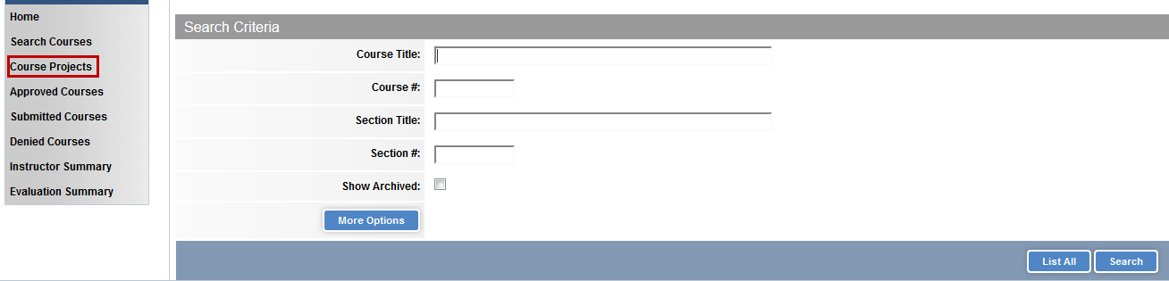

* Enter information about your course. Depending on your system’s configuration, you may have different fields. Note: Fields in **red** are required.
* Click **Create Instructor Led Course** to create the course. .Click **Cancel** to return to previous screen.

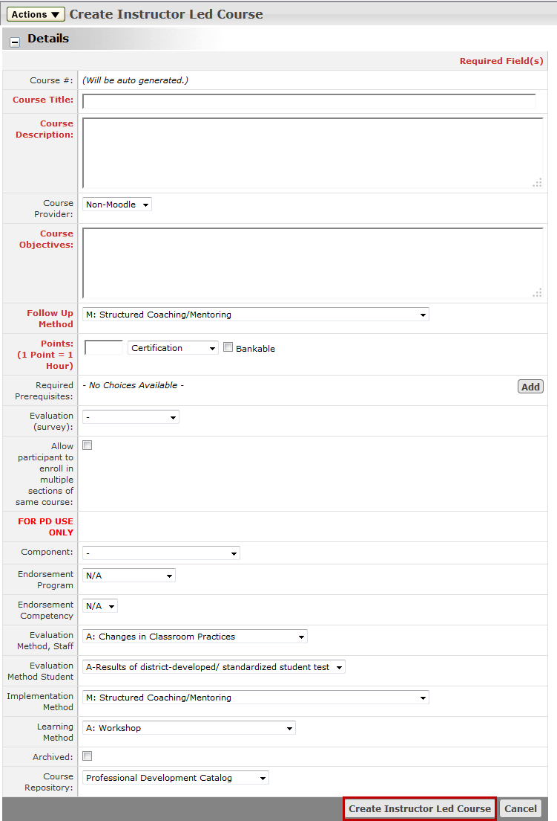

**Note:** Selected **Course Provider** **cannot** be changed after the course has been created.

## Targeting Your Audience

* Under **Settings**, set the parameters for your course. Depending on your system’s configurations, these may be slightly different.
* **Availability:** Set locations for your course
* **Required Demographics:** Select groups that are required to take the course.
* **Recommended Demographics:** Select groups for whom the course is recommended
* **Restricted Demographics:** Restrict course attendance to these selected demographics
* **Competencies:** Align course objectives to rubrics.

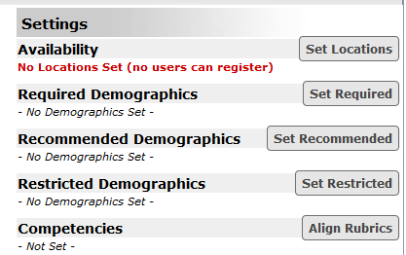

* Scroll down and click **Done** to complete the process.

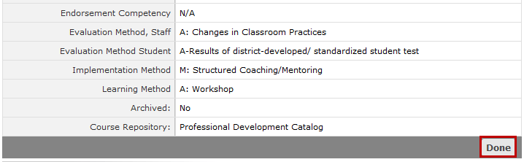

* For self-paced courses for which there is an approval process, click **Submit for Review**
* For instructor-led courses, return to this screen to create sections for your course.
* To delete a course, click the **Actions** button and select **Delete Course** from the menu.